**Executive Summary**

Our company undertook a thorough assessment of two facial recognition technologies: the open-source face_recognition library and Amazon Rekognition to establish an effective facial biometrics system for monitoring employee attendance post-remote work era. This evaluation was comprehensive, considering technical performance metrics as well as broader business implications, such as system complexity, operational costs, and maintenance requirements.

**Technical Analysis**

*Face-to-Face Comparison (figure 1, 2 &3)*

* face_recognition: Exhibits high accuracy, recall, and precision, beneficial for diverse face matching. However, its more evenly distributed similarity scores, even for actual matches, can lead to lower perceived confidence in results, increasing false positives.
* Amazon Rekognition: Delivers high precision, identifying accurate matches with high similarity scores, a key advantage for minimizing false positives in security-critical environments. Although its recall is lower, meaning some actual matches might be labeled as non-matches with extremely low similarity scores.

*Face Detection in Images (figure 4, 5 & 6)*

* Face_recognition: Struggles with reliably detecting faces in images, often failing to recognize some faces and misclassifying others. Additionally, most faces it does detect are not assigned very high similarity scores. Despite having a good facial comparison performance, this challenge imply the system is adept at identifying a single, unobstructed face, yet its performance diminishes when faced with multiple faces or visual noise, leading to a tendency to underperform in more complex visual scenarios.
* Amazon Rekognition: excels in facial detection, significantly outperforming in both accuracy and reliability. It consistently assigns very high similarity scores to matched faces, and these matches are accurately identified.

**Business Implications**

* The face_recognition library, despite its affordability and ability to match a wide range of faces, presents certain limitations, particularly in accurately recognizing individual faces in images with multiple people. This technical complexity, coupled with potential security vulnerabilities, necessitates significant in-house expertise for effective deployment and ongoing maintenance. Such requirements could lead to resource constraints, higher costs, impacting the overall efficiency of our business operations.
* Meanwhile Amazon Rekognition demonstrates a key advantage in its robust ability to accurately recognize multiple faces in images, even amidst noise and obstructions. This capability is essential for efficient and secure employee attendance tracking in a dynamic work environment. While it carries higher costs, it offers a more predictable expense model and reduces the complexity of maintenance. These factors, combined with its technological excellence, make Amazon Rekognition a more suitable and sustainable choice for our business's long-term operational needs.

**Strategic Business Perspective**

* Scalability and Future Growth: Amazon Rekognition's cloud-based solution is more adaptable to company growth and changing needs, a significant advantage for a forward-thinking company like ours. Companies that do not leverage cloud technology are at a significant risk of falling behind their competitors who are embracing this technology, especially in the near future.
* Data Privacy and Security: The face_recognition library offers enhanced data control, ideal for stringent privacy policies, but necessitates strong internal security. Amazon Rekognition, with its robust security features, involves cloud storage, raising data privacy concerns. However, Amazon's reputation and compliance with global security standards largely alleviate these worries. This balance of trust and technological efficiency makes Amazon Rekognition a reliable choice for our company's needs.

**Conclusion and Recommendation**

In balancing technical and business considerations, Amazon Rekognition stands out as the preferred choice for our company. Its precision, eas of use, scalability, and reduced maintenance align with our strategic objectives, even considering the possible higher cost. Although the face_recognition library is more budget-friendly and offers more control over data, its technical complexities, higher maintenance cost and potential security issues are less suited for our present and future needs. Most importantly, embracing advanced services from a technology leading company like Amazon positions us well in a market increasingly driven by automation and artificial intelligence. Amazon's comprehensive offerings and seamless integration capabilities make it a valuable partner for future technological expansions.

**Appendix**

Figure 1

Confusion matrix of Amazon Rekognition and face_recognition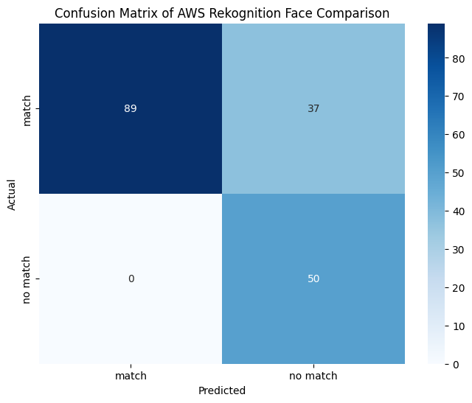

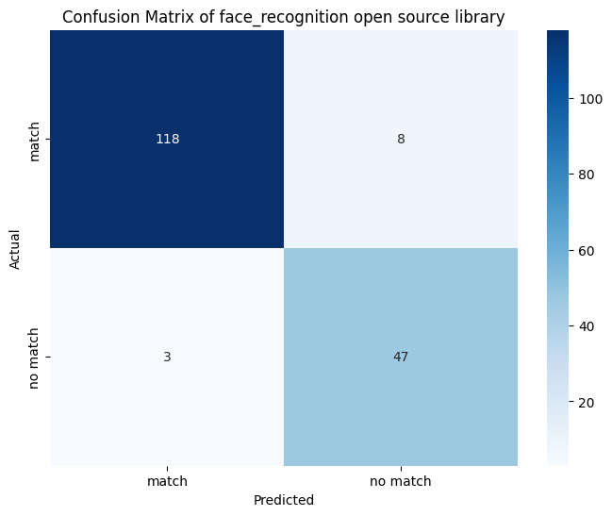

Figure 2

*Table of accuracy, precision, recall*

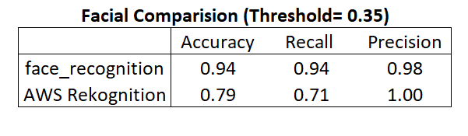

Figure 3

*Similarity distribution for facial comparison* 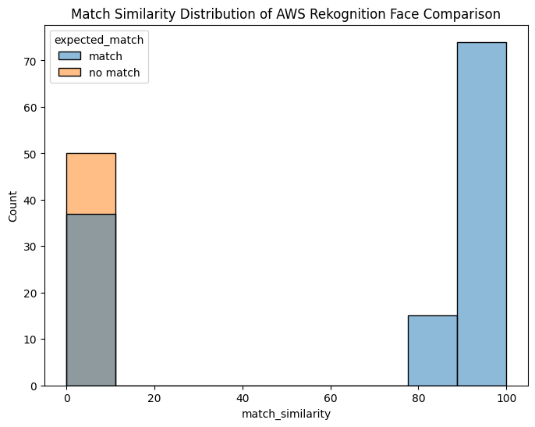

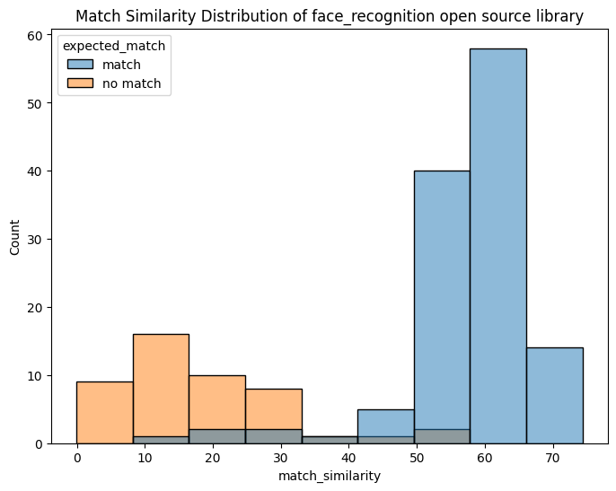

Figure 4

*Similarity distribution for facial detection in images*

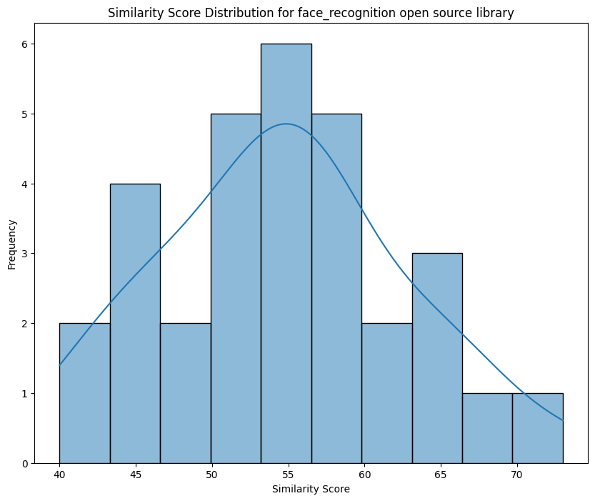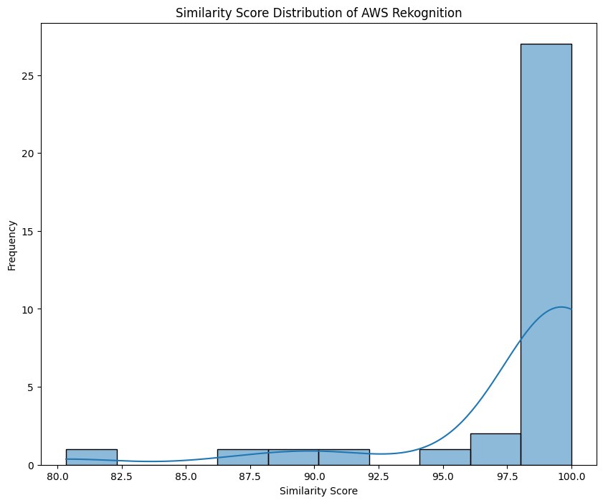

Figure 5

*Labeled images produced by face_recognition*

Image 1



Image 2

Figure 6

*Labeled images produced by Amazon Rekognition*

Image 1



Image 2

